Python Major Assignment

1.Findthedatatypeofthesetwodeclaration:x=5y="John

x=5

y="John"

print(type(x))

print(type(y))



2.Checkwhetherthefollowingsyntaxisvalidorinvalidfornamingavariable.:Example:abc=100#validsyntaxi.3a=10ii.@abc=10iii.a100=100iv._a984_=100v.a9967$=100vi.xyz-2=1003.

i.Invalid ii.Invalid iii.Valid iv.Valid v.Invalid vi.Invalid

3. CheckifelementexistsinlistinPython:list=test_list=[1,6,3,5,3,4]

test_list = [1, 6, 3, 5, 3, 4]

if 3 in test_list:

print('3 exists in the list.')



test_list = [1, 6, 3, 5, 3, 4]

if 9 in test_list:

print('9 exists in the list.')

else:

print('9 does not exist in the list.')



4. from datetime import datetime

user_input = input("Enter any text: ")

print("You entered:", user_input)

print("The current date is:", datetime.now().strftime("%B %d, %Y"))

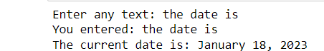

5. print(9//2) and print(9%2)

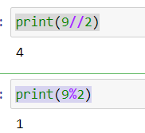

6. count = 1

while count <= 10:

print(count)

count += 1

output

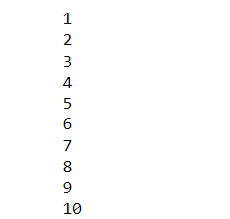

7. number = int(input("Enter a number: "))

sum = 0

for i in range(1, number+1):

sum += i

print("The sum of all numbers from 1 to", number, "is", sum)



8. for i in range(1, 51):

if i % 3 == 0 and i % 5 == 0:

print("FizzBuzz")

elif i % 3 == 0:

print("Fizz")

elif i % 5 == 0:

print("Buzz")

else:

print(i)